NEWS RELEASE
Hazmasters Inc.
651 Harwood Avenue North • Ajax, ON • L1Z 0K4
877-747-7117 • www.hazmasters.com

Hazmasters Opens New Branch in Saint John, New Brunswick

SAINT JOHN, NEW BRUNSWICK, February 3, 2016: Hazmasters is proud to announce the opening of our branch in Saint John, New Brunswick!

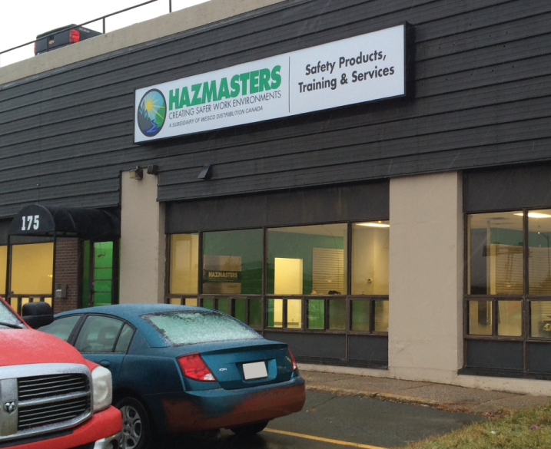
Our newest branch is 8000 square feet to meet all your safety product and service needs. In addition to our extensive line of safety and abatement products, the Saint John branch also offers an expanded product offering of tools and accessories, fasteners and other MRO products.

We invite you to stop in to browse our showroom or give us a call to have our one of our knowledgeable and experienced representatives come to your location to explore solutions for your safety concerns. Our commitment to our customers is to bring the expertise and knowledge in creating a safer work environments to ensure you have the right safety products and skills, and workers who are trained and educated. Our business is concentrated on your safety needs.

The Hazmasters Saint John team is looking forward to welcoming you to our new location!
- Pat Graves, Branch Operations Manager
- Jason Murray, Customer Sales & Service Representative
- John Henderson, Business Development
- Gene Lapointe, Business Development

Hazmasters’ Saint John branch is located at 175 Hilyard Street, Saint John, NB. They can be reached by calling 506-646-0345.

Stay tuned for details about our Grand Opening event, happening in May!

About Hazmasters

Hazmasters is a leading provider of workplace safety equipment, training and services. Our approach to our customer’s safety program and training is about more than the products – it’s about how we can support you in creating safer work environments and building a safety culture. Providing safety products and training with exceptional service since 1989, we are focused on sharing our safety expertise through service and education in a wide range of markets.

Our 14 locations across Canada offer 24/7 emergency support, extensive safety product inventories, service centres and education classrooms to quickly respond to your safety needs.

Hazmasters is a subsidiary of WESCO Distribution Canada.

Contact: Shelby Cranley, Marketing Coordinator | shelby.cranley@hazmasters.com | 905-231-0011 ext. 306

